Name: ________________________________________________________ Date: ______________________________
Math Homework
January 13
DUE: Friday, January 20th
Directions: Choose one word problem to solve. Show all work in the bottom box.
Remember to show your thinking (models) and include an equation, labels, and the final answer written in a complete sentence.
A  Southern Oil Company just received 6,300 tons of oil. They need to split it into their 70 oil containers. If each container gets the same amount, how many tons of oil will go in each container? | B  Over the last 6 days, Andrew read a total of 480 minutes. If he read the same amount each day, and plan to continue the same amount tomorrow, how many minutes will he read tomorrow? | C  Taylor is doing a jumpathon to raise money for heart disease. She has jumped for 5 hours, and has a total of 450 jumps. If she jumped about the same number of jumps each hour, how many jumps has she done in 1 hour?

Show work below:

Skill Review:
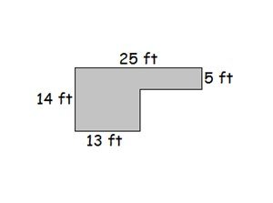  HINT: Don’t forget to find missing sides. | What is the area of the figure?  What is the perimeter of the figure?

Dreambox
Mon | Tues | Wed | Thurs | Fri | Sat | Sun | TOTAL  MINUTES

All students should complete at least 30 minutes ON TASK.

Fluency

I am working on ________________________________ level in fact fluency.
Write 10 example facts related to the level that you are practicing.
Choose the ones most difficult for you:

I practiced my fluency by _____________________________________ .
Ideas/ Suggestions: www.multiplication.com, Math Magician (online), www.ixl.com
Flash cards, Fluency songs on YouTube, partner practice or multiplication charts.

Parent Signature: __________________________

